Taking part in a Google Meet
– Pupils’ Guide
Your teacher may invite you to take part in an online meeting using Glow Meet through the Google Classroom. This is just like being with your teacher and classmates in a virtual classroom and our school rules (Be Respectful, Be Safe and Be Ready to Learn) are important here too.

Be Safe | Be Respectful | Be Ready to Learn
Make sure you are working in an open space near an adult. | Speak respectfully to everyone in the online classroom | If you are taking part in the meeting make sure you are there on time.
Let others around you know that you are having an online meeting. | Use the ‘hands up’ tool to make sure you aren’t  talking over others. | Begin with your camera off and microphone muted until your teacher tells you to switch them on.
Make sure you are dressed appropriately. (As you would if you were going outside). | Use the chat function to sensibly answer or ask  questions. | Follow instructions given by your teacher.
Do not record or take photos during the  meeting or share  these on social media. | Only add comments or questions relating to the meeting. | Be prepared with any materials your teacher has asked you to bring e.g. paper, pencil.
If you see or hear  anything which makes you feel uncomfortable, please let an adult know straight away. | Use appropriate language or emojis and make sure all posts are respectful. | Actively take part in the meeting  e.g. nod or use a thumbs up if on mute to show you understand or agree.
 | Say “thank you” to everyone at the end of the meeting and press to hang up or end the meeting. | When speaking, look into the camera.

Taking part in Google Meet
– Parents’ Guide
Your child’s teacher may invite them to take part in an online meeting or lesson using Google Meet. Please take time to read the information below and discuss the Pupils’ Guide with your child/children
Online Meetings
Pupils will be invited to have a short meeting. This will allow pupils to interact with their teacher and classmates as they would do in their classroom. The focus of these will be Health and Wellbeing and evaluating learning as well as introducing new learning concepts.

Useful Advice
- Parents should be aware of when their child is engaging in a Google Meet.
- Videos from within Glow are not allowed to be removed to other social media platforms and cannot be shared outwith the Google Classroom.
This is part of the Glow user agreement (please see following document for further information). https://glowconnect.org.uk/security-and-privacy/glow-community-rules/
- Make sure others in the household are aware a meeting is happening.
- Make sure your child is in a suitable area of the home.
- Listen into meetings if necessary.
- Support your child during the meeting, only if you feel this is needed.
- As this is an opportunity for pupils to engage with their teachers, please do not ask questions or speak for your child during the meeting.
- Contact the school if you have any concerns regarding meetings.

Accessing the Google Meet
- Log into your Google Classroom
- The Google Meet link will appear in a Post on the Stream at the time of the Meet.
- Click the link and select Microphone off. Please leave your camera on.
- Use the circle in the bottom right to change the background screen to help with privacy settings.
- Once you have done those things select Join Now in the middle of the screen.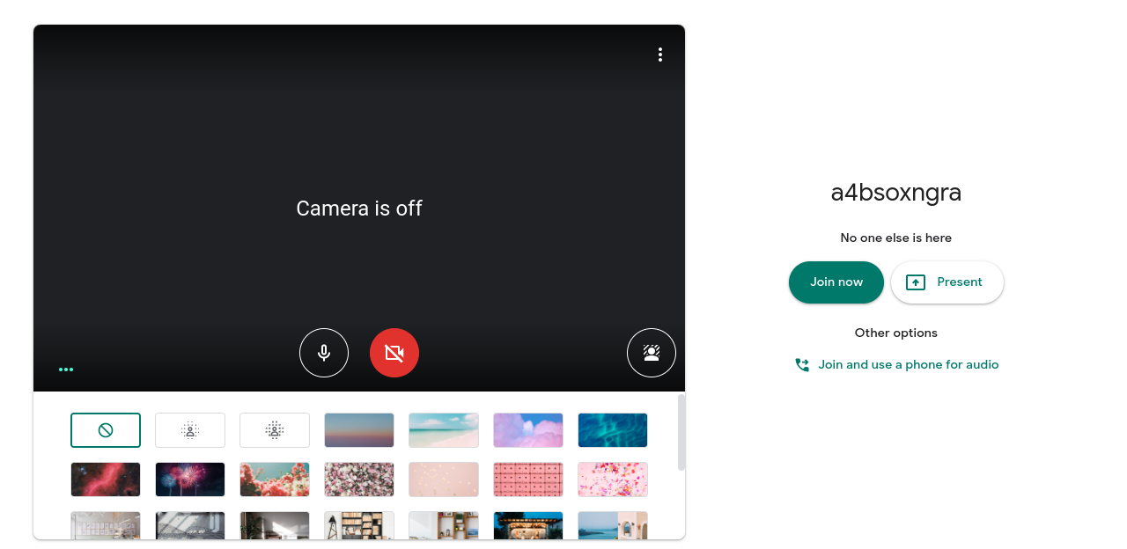

- You are now in the meeting live with your teacher and classmates!
- Remember to follow the school rules - Be Safe, Be Respectful and Be Ready to Learn.
- If your mic is muted you can still nod or give thumbs up to show you agree. If you would like to speak, press the Hands up button and your teacher will know you are waiting to say something. When it is your turn to speak, remember to click the Microphone button again so everyone can hear you.
- When the Google Meet is finished, the teacher will end the session or you can say thank you and press the telephone button to hang up.
- We are looking forward to seeing you soon! Please check the table below for your class times - we will begin with Wellbeing Wednesday on Wednesday 20th Jan. Pop it in your diary!

Monday  Introduction to learning this week | 9am  P1W & P1B | 9.30am P1/2M & P2A | 10am  P7N & P7R | 10.30am P5B & P5R | 11am P4B & P4S | 11.30am P6C & P6M | 12pm  P3L & P2/3
Wednesday  Wellbeing  Meeting | 9am  P1W & P1B | 9.30am  P4S & P4B |  | 10.30am P5B & P5R | 11am  P1/2M & P2A | 12pm  P3L & P2/3 | 1.45 pm P6C & P6M | 2.15pm  P7N & P7R
Thursday  Review of our week |  |  |  |  |  |  | 1.45pm  P6M & P6C | 2.15pm  P3L & P2/3
Friday  Review of our week | 9am  P1W & P1B | 9.30am P1/2M & P2A | 10am  P7N & P7R | 10.30am P5B & P5R | 11am  P4S & P4B

