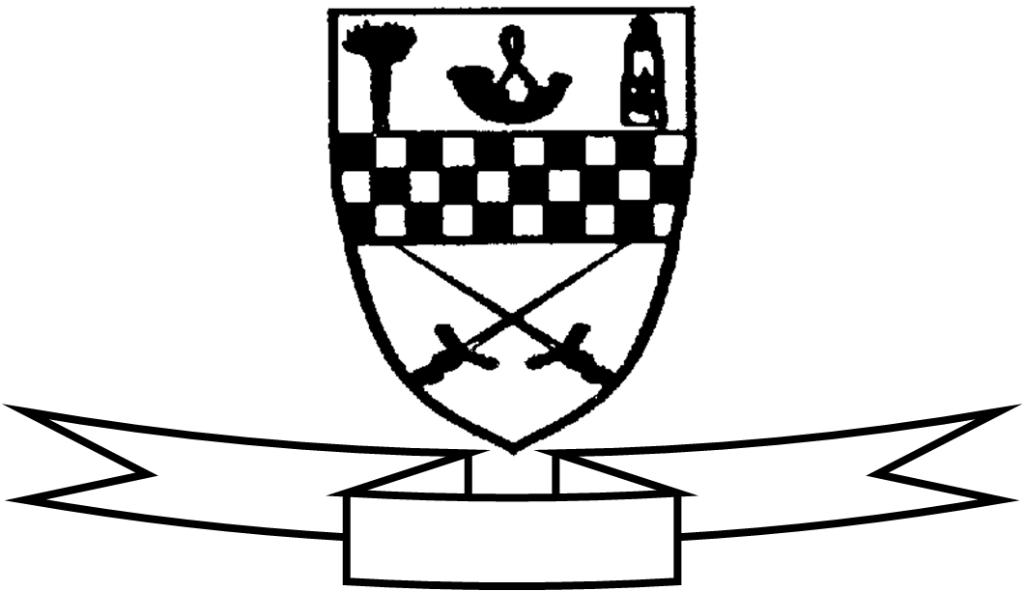
Aim high
Be proud
Celebrate success

Curriculum For Excellence
Class P5A Teacher’s Name: Miss Adams Term 2 Oct-Dec 2015
Areas of the Curriculum
Language
Reading This term the children will be reading for information linked to our Rainforest topic. They will use a variety of sources to locate relevant information and begin to evaluate the usefulness of a text for a given purpose. In reading groups the focus will be on answering and asking different types of questions in order to investigate plot and character in their reading book. Throughout our reading groups we will look carefully at the tools needed for reading, for example grammatical knowledge, fluency strategies etc.
Writing The focus of this term’s writing sessions will be creating a range of different types of poetry, writing a variety of instructions and report writing linked to our topics across the curriculum.
Listening and Talking The children will continue to build upon the skills they have been developing during talking partner and group work sessions, with a focus on reaching an agreement and compromising. The children will also be given a homework task to prepare a personal talk linked to our Rainforest topic which they will then present back to the class. We will also continue with our weekly circle times.
Numeracy We will be continuing to work on place value, addition/subtraction and multiplication/division. The children will work on a range of mental strategies using their times table knowledge as well as practising formal written methods and solving written problems. The children will continue to practise their times tables during the course of the term.
Maths We will be looking at time and measure. Children will work on telling any time using analogue and digital clocks, read and use every day timetables and work on duration activities. Our measure topic will develop the children’s skills of estimation and practical measurement which will be applied to our rainforest topic.
Health and Well Being The children will continue to work through the activities in the upper school programme of Cool in School.
Enterprise The children will be involved in preparing Christmas cookies to sell at our Christmas fair. They will create both the cookies and the packaging for our product.
Social Subjects This term P5 will be learning about The Rainforest. They will be applying their mapping and data handling skills as they learn about the layers of the Rainforest and the classification of animals living there. They will also be learning about the impact of deforestation on the animals and people who live in these areas of the world.

Expressive Arts
Art and Design The children will be investigating using a variety of mixed media.
Drama The children are working with Ms Aird this term.
P.E Children will work with Miss Robson on Thursdays. The second session will be on a Wednesday. The children will be developing their skills in team invasion games such as football, hockey and basketball.
Music Children will working with Mrs Callaghan on a Wednesday and preparing for our Christmas Concert: Hosanna Rocks!

Specialist Subject and Teacher | Day Taught
Drama | Monday
P.E. | Thursday
Music | Wednesday

Other information:
Please ensure that your child has indoor shoes which can be kept in school and a full P.E. kit every week.
If possible, please ensure that your child brings a bottle of water for drinking during the day.
Can all dinner money be brought to school in a purse/wallet/envelope with your child’s name on it. Any other monies should be in a sealed and labelled envelope please.

