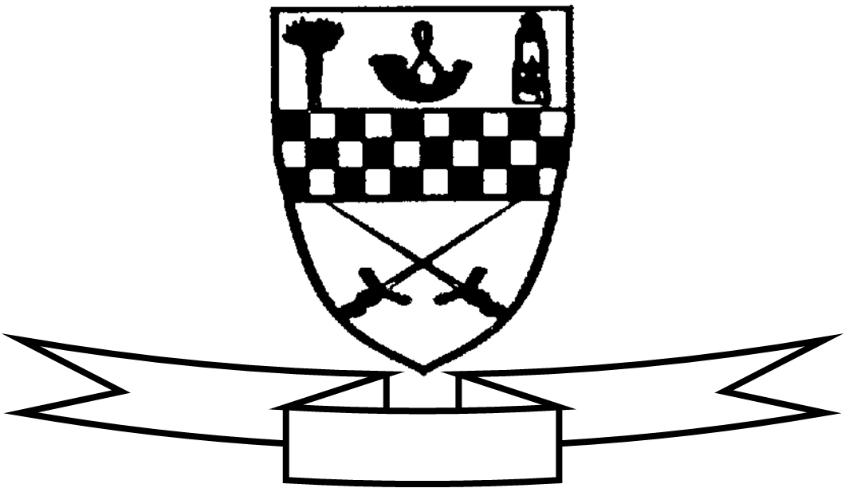
Aim high
Be proud
Celebrate success

Curriculum For Excellence
Class P3 Teacher’s Name Mrs McGee/ Mrs Anderson Term 2 October - January
Areas of the Curriculum
Language
Reading: Understanding and evaluating texts. The children will read “The Owl who was afraid of the Dark”, and use this to complete a number of tasks to develop their understanding of more complex text.
Reading for enjoyment. Children will be taken to the library regularly as well as encouraged to use the class library each day. We are encouraging the children to read books of their choice at home.
Writing: This term children will learn about the features of poetry and they will create their own poems. They will also be developing their use of imaginative language through story writing. They will be learning to use common nouns and proper nouns within their work.
Listening and Talking: The children will listen to others reading from their novel study. They will listen to poems and try to recreate their own versions in a similar style.
Maths: The children will be beginning to learn to tell half past, quarter to and quarter past times using analogue and digital clocks. The children will learn to identify different 2D and 3D shapes and their properties. The children will apply their knowledge to construct models using these shapes.
Numeracy: The children will continue to learn to multiply by 2, 3, 10 and 5. There will be a continued focus on addition and subtraction strategies. We will be introducing addition of tens and ones set out in columns. They will then apply their knowledge to solve word problems.
Health and Well Being: The children will continue to develop their skills in balance, throwing and catching and dribbling of balls. The children will continue to discuss their well being and views on friendships within the classroom. We will discuss hygiene and cleanliness and apply this knowledge in everyday routines.
Science: The children will learn about the Sun the Moon and the Stars, linked to their novel study and will also investigate to find out about owls and other nocturnal animals. They will also develop skills in observing, predicting and recording the results of experiments.
ICT/Technologies: The children will use computers and learn how to input their own user names and passwords in order to access suitable sites. They will also be beginning to use word processing when typing their poems. Within maths they will be developing and using problem solving strategies to construct models.
RME: This term the children will be learning to describe the simple key features of the values of Christianity, expressed in stories.
Expressive Arts
Art and Design The children will use a variety of media to create pictures related to the Novel Study, “The Owl who was afraid of the Dark.”
Drama The children will take part in role play activities to learn drama technique and language.

Specialist Subject and Teacher | Day Taught
Drama – Cheryl Aird | Monday
P.E – Class Teacher | Monday (both classes)
P.E. – Miss Robson | Tuesday (Both classes)

Other information:
Please ensure that your child has shorts and t-shirt for both gym days. Gym will be done outside on a Monday if the weather is suitable. Please ensure that your child has appropriate outdoor clothing for this i.e. joggers.
Both classes will be baking Christmas treats to sell at the Christmas Fayre on 28th November 2015. Hopefully you will be able to come along and support P3 in their school fundraising.

