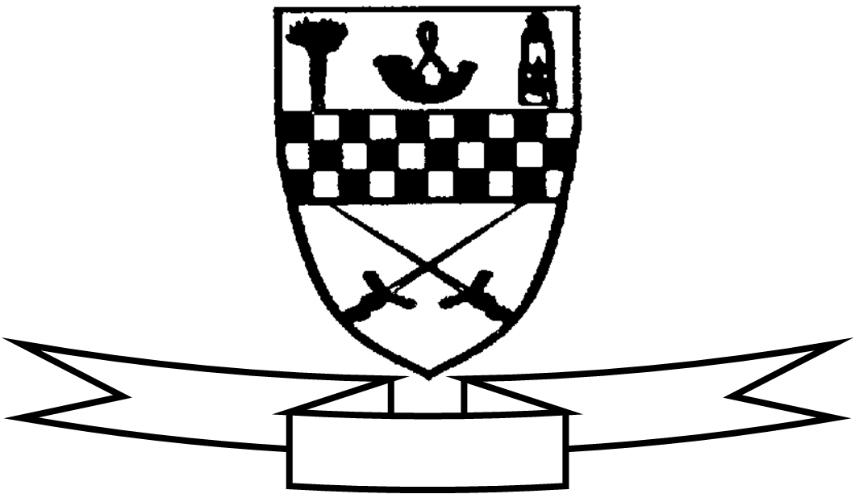
Aim high
Be proud
Celebrate success

Curriculum For Excellence
Class P6W Teacher’s Name Ms Wood Term 3 Apr-Jun 2015
Areas of the Curriculum
Language
Reading This term the focus of the reading activities will be understanding, analysing and evaluating texts. The majority of this work will relate to their class novel- The Desperate Journey. Children will also continue with their home reader novel and will be expected to read texts of their own choosing throughout the term.

Writing The focus for this term is writing instructions and discursive essays. We will be looking at ordering in chronological steps, using time connectives and structuring arguments..

Listening and Talking The children will research, prepare and present a talk on the Mary Queen of Scots. They will also be doing listening activities to practise comprehension and visual memory skills.

Maths This term the children will complete the elements of time ranging from the 24 hour clock to precise timings using a stop watch. They will solve problems based on scrutinising timetables. They will also explore measurements for length, weight and volume.

Numeracy The focus this term will be on mental maths strategies that will be taught and reinforced through regular class activities. They will apply the four operations to range of numbers extending up to the millions. They will have opportunities to apply their numeracy knowledge to solve a range of real life problems with a relevant link to their IDL project.

Health and Well- Being This term’s focus will be on personal safety with the internet and fitness for Spots Day.
Social Studies The children will undertake a project on Mary Queen of Scots. This will include research into the history and culture and include a visit to Holyroodhouse Palace where they will study the costumes at court. The homework challenge is creating a mini/zigzag book detailing two stories from her life and preparing a talk around their book.
Science Fitness tests and breathing. Study of trees in visit to local wood.

RME This term the children will undertake work on comparing Christianity and Protestantism in the 16thC linked to their IDL on Mary Queen of Scots.
Modern Languages Children will continue to revise greetings in French. They will also be consolidating their basic vocabulary in Dutch.
Expressive Arts
Art and Design Linked to their IDL Mary Queen of Scots including portraits and miniatures.
Creating art in the environment during the study in the woods with natural found materials.
Drama Using drama conventions to tell the story of Mary Queen of Scots
P.E Personal fitness and volleyball
Specialist Subject and Teacher | Day Taught
Drama Cheryl Aird | Monday
P.E. – Mrs Robson | Tuesday
P.E - Ms Wood | Friday -Bikeability

Other information:
P.E. – Tuesday. Please ensure that your child brings a full P.E. kit - shorts, t-shirt for indoors and joggers and sweatshirt for outdoor. Both indoor and outdoor gym shoes would be useful.

