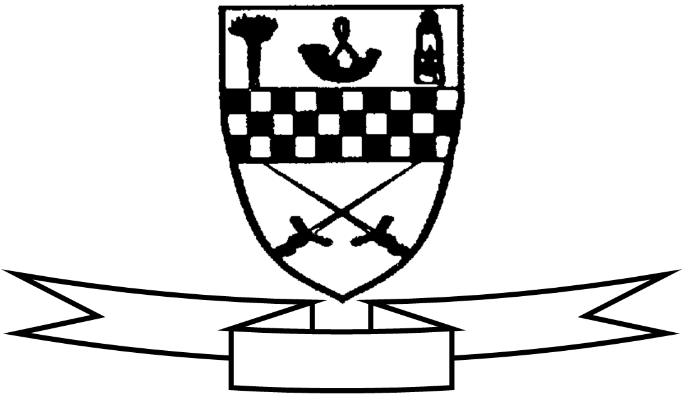
Aim high
Be proud
Celebrate success

Curriculum For Excellence
Class P5 Teacher’s Name: Mrs Wilson and Mrs Bee Term 4 Apr-Jul 2015
Areas of the Curriculum
Language
Reading During our studies on the Wars Of Independence the children will focus on reading for information. The children will refine their skimming and scanning skills, find relevant information, summarise passages and create new texts. This term the class will also be undertaking a novel study of David Walliam’s Billionaire Boy
Writing Our writing this term will include report writing and instructions. This ties in with the work the children are doing on reading for information.
Listening and Talking Sex Education and our Art Exhibition enterprise will provide opportunities for listening and talking.
Numeracy Our main focus in numeracy this term will be investigating the link between fractions, decimals and percentages and applying this knowledge to practical activities. We will also continue to work on addition and subtraction.
Maths The children will be working on identifying different kinds of angles and position and movement using the 8 point compass.
Health and Well Being The children are about to start work on the Living and Growing Sex Education programme. This covers changes in puberty, how babies are made and how babies are born. The children have been encouraged to discuss each lesson with you at home as it takes place.
Enterprise P5 are looking forward to organising the annual school Art Exhibition which will take place on the 11th June. The children will be responsible for all aspects of the running of the exhibition and we look forward to seeing you at this lovely event.
Social Subjects The main area of study in social subjects is the Scottish Wars of Independence. We will compare and contrast life in medieval Scotland to life today and will look at different sources of primary and secondary information.
Technology Miss Rankin from the Technology Department at Beeslack High School is undertaking a project with the class on bridge making.
Expressive Arts
Art and Design The children will work with a range of media this term including paint, and collage linked with the Scottish Wars of Independence topic.
P.E Children will work with Miss Robson on Tuesdays. The majority of children are taking part in weekly ski instruction at Hillend.
Drama activities with the drama specialist

Specialist Subject and Teacher | Day Taught
Drama | Monday
P.E. | Tuesday

