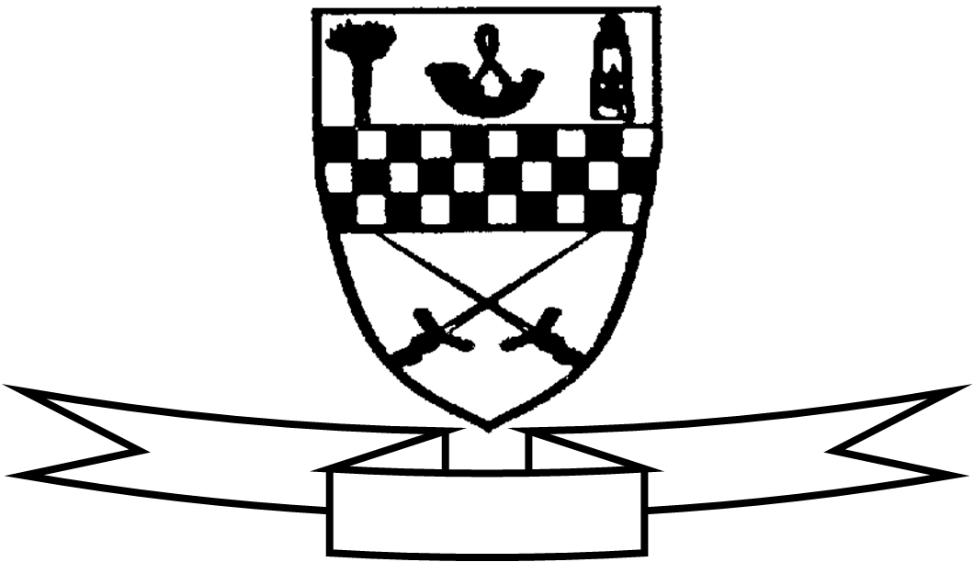
Aim high
Be proud
Celebrate success

Curriculum For Excellence
Class P5 BW Teacher’s Name: Mrs Bee / Mrs Wilson Term 3 Jan - April 2015
Areas of the Curriculum
Language
Reading This term the children will take part in the Mauricewood Reading Challenge. Each child will be expected to read a number of books and complete book related activities at home. The major emphasis is on encouraging pupils to enjoy reading and to share what they have enjoyed. The children are also doing a Literacy topic on Scottish stories, songs and poems. Activities will focus on looking at the features and structure of different genre and comparing texts.
Writing This term’s writing sessions will focus on creating stories and poems using Scottish folk and fairy tales as a stimulus. The children will be using language to create mood and atmosphere in their writing and they will be able to choose appropriate features and layout according to the task and audience.
Listening and Talking We have enjoyed using Scots words across our learning. The children who worked very hard to learn their Scots poems gained a lot from performing these before an audience. The children will also continue to practise their communication skills when doing co-operative learning tasks in class.
Numeracy Primary 5 are working on finding fractions of numbers this term. As this involves using times tables, practise of these will be ongoing and the children should be practising their tables at home regularly, as this really helps with confidence when working with fraction problems. We will also be starting to work with decimal numbers and linking this work to their fraction knowledge.
Maths This term the children will undertake work on information handling and time.
Health and Well Being The main focus in health and well being this term is looking at safety around medicines and the dangers of smoking.
Science The children will be undertaking a project on The Seashore this term. They will be investigating the diversity of living things found at the seashore and how they have adapted to survive in this environment. They will also do work on classification and food webs. We are going on a class trip to Deep Sea World and information on this will be issued to you separately.
Expressive Arts
Art and Design Children will use a variety of media to create art work relating to the seashore topic.
P.E Children will work with Miss Robson on Tuesdays. Class P.E. will take place on a Wednesday. The focus in both sessions will be on stamina, strength, determination and resilience in order to increase fitness levels.
Music The children will be learning and performing a range of Seashore songs at their class assembly.
Specialist Subject and Teacher | Day Taught
P.E. | Tuesday
Music | Wednesday

Other information:
Deep Sea World class trip Monday 2nd February
Science Week Monday 9th February Presentation for parents Friday 13th February

Class Assembly Friday 27th February 9.15am

