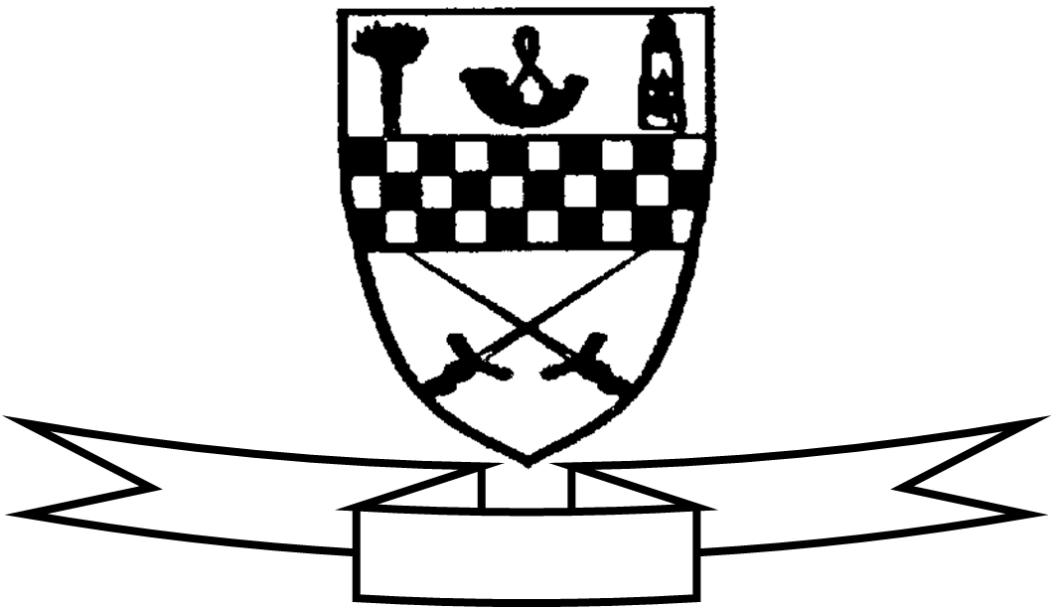
Aim high
Be proud
Celebrate success

Curriculum For Excellence
Class P3 Teacher’s Name Mrs Cunningham/Mrs McGillivray/Mrs Barr Term 3 January – April 2015
Areas of the Curriculum
Language
Reading: Reading for enjoyment. Children will be taken to the library regularly as well as encouraged to use the class library each day. We are encouraging the children to read books of their choice at home. The children will be learning more about how to find and borrow books in the library with a focus on fiction and nonfiction and alphabetical order.
Understanding and evaluating texts. The children will read a variety of Scottish texts. They will develop an understanding of the use of Scottish language.
Writing: This term children will learn about the features of poetry and they will create their own poems. They will also be learning how to make informative and eye catching posters or fact files.
Listening and Talking: The children will listen to a variety of Scottish stories, songs and poems. They will learn a poem to recite to the rest of their class with a focus on the use of expression and pronunciation.
Maths: The children will be learning to tell half past, quarter to and quarter past times using analogue and digital clocks. The children will learn to identify different 2D shapes and their properties. The children will apply their knowledge of 2D shape to make tiling patterns.
Numeracy: The children will continue to learn to multiply by 2, 3, 10 and 5. They will begin to divide by 2 and explore the links between multiplication and division. There will be a continued focus on addition and subtraction strategies. They will apply their knowledge to solve problems involving money.
Health and Well Being: The children will learn about the safe use of medicines.
Social Studies: The children will learn to interpret a map of Scotland and use terms such as plans and symbols.
Science: The children will learn more about the properties of different materials. They will also develop skills in observing, predicting and recording the results of experiments.
Technologies: The children will use an iPad to make a short film about their views on learning and mindset. This will be presented to other classes.
RME: This term the children will be learning about both Christianity and Islam.
Expressive Arts
Art and Design The children will use a variety of media to explore the works some famous artists and practise some of their techniques.
Drama The children will take part in role play activities based on the Romans topic.
P.E The children will follow the Basic Moves programme indoors with the PE specialist and they will learn steps to take part in Scottish Country Dancing with the class teacher.

Specialist Subject and Teacher | Day Taught
Drama – Visiting specialist | Monday (P3C)
P.E – Class Teacher | Monday (both classes)
Music | Wednesday (P3MB)
P.E. – Miss Robson | Thursday (Both classes)

Request for expertise or resources:
If you would be interested in helping in the classroom please speak to your class teacher. We would be particularly grateful to anyone who could help during writing or practical sessions related to topic work.
Other information:
Our Roman celebration will take place on Thursday 5th February from 1:30 – 2:40. Parents and carers are invited to attend this exciting event. Please see separate letter for more details.

Please ensure that your child has shorts and t-shirt for both gym days.

